ELEC 5150/6150 Information Security

LAB 3 REPORT
Xiao Lin & Yuanqi Chen

Abstract
In this lab, we are going to learning how to realize public key crypto by RSA and implement the signature and verify the signature by JAVA as well as the encryption and decryption of RSA with a random number. In the bonus, we realize the android implement and the using the RSA to transmit the AES256key between client and server.

Introduction
RSA is a algorithm both suitable for encryption as well as signature so it is a important algorithm in public key encryption. We are going to implement the encryption and signature using RSA in eclipse and we also have finished the implement in the android platform.

Design
Step 1
Generate a 2048-bit public-private key pair for RSA.

Here is the private key:
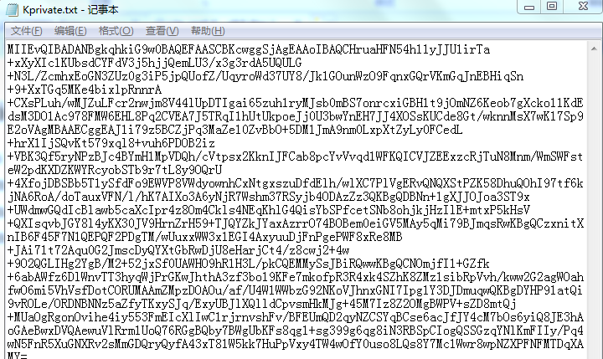

Here is the generated public key

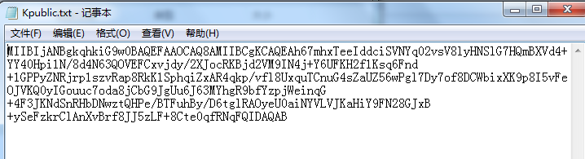
Step 2
Create a SHA-256 hash using the text file in Lab 1. Save the hash in Hash.txt
Here is the generated hash:
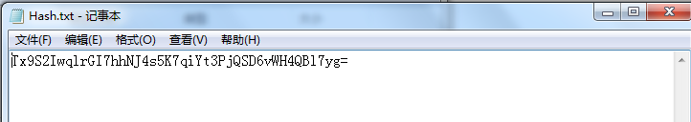
Step 3
Create a signature using SHA-256 with RSA decryption .
Here is the generated signature:
Step 4
Verify the signature.
Here is the verify result:
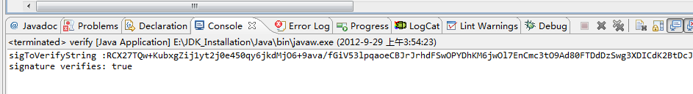
Step 5
Generate a secure random number, save the random number in RAND.txt
The random number in BASE64:
Step 6
Encrypt the random number using public key:
Here is the encrypted file in BASE64:
Step 7
Decrypt the encrypted file using the corresponding private key.
Here is the decrypted file and original file in BASE64:
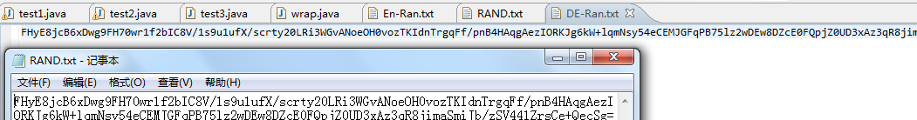
Step 8
Generate a public/private key pair for ECDSA for Binary Curve B-571.
Here is the capture of private key and public key:
Private key:
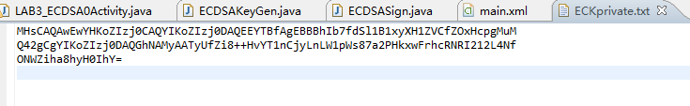
Public key:
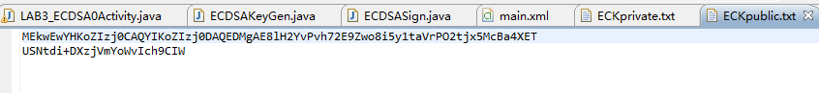
Step 9
Create a signature using SHA-256 with ECDSA decryption
Here is the signature:
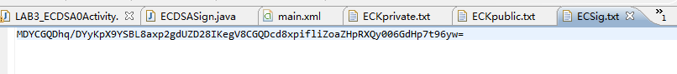

Step 10
Verify the signature
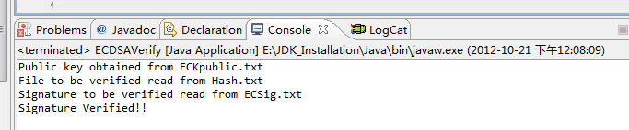

Bonus:

- Write a client and server UDP code to perform
- Server has the private key and the client has the public key. Client generate a random number and use the public key to encrypt the random number and sent to Server
- Server decrypt the encrypted random number
- Server and Client use the same random number as seed to generate a AES-256 key and save it into file
Here are the screen captures:

Run the client and server
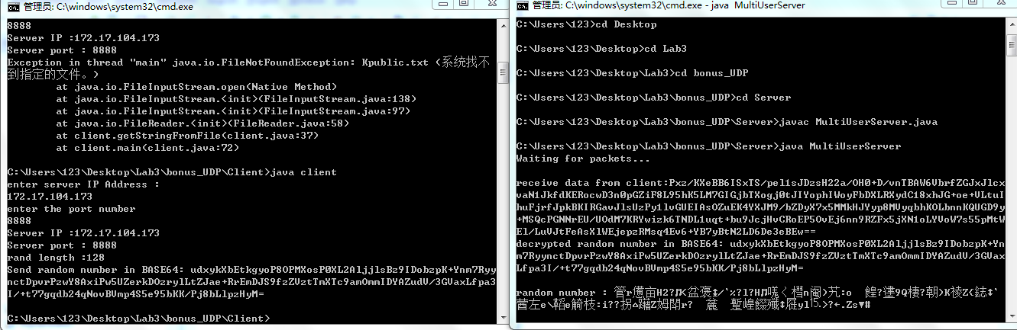

Random number in client and decrypt random number in server
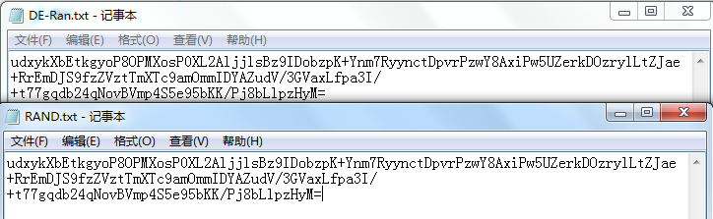
AES-256 key in client and AES-256 key in server
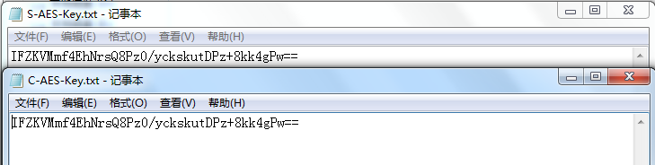
- Implement in android
Step 1
Generate public/private key pair for RSA.
Here is the the UI
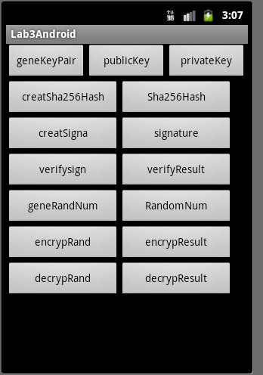
Click geneKeyPair
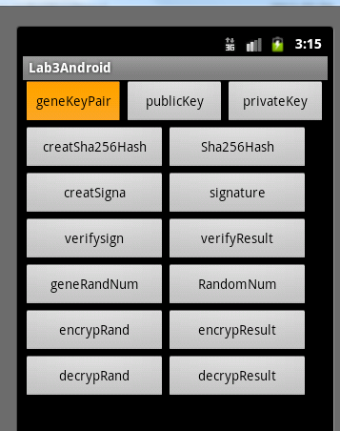
Click the publicKey button to show public key
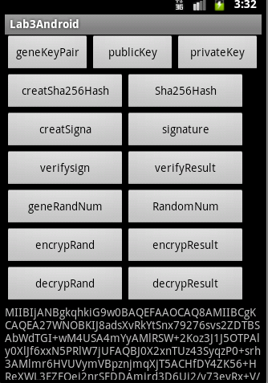

Click the privateKey
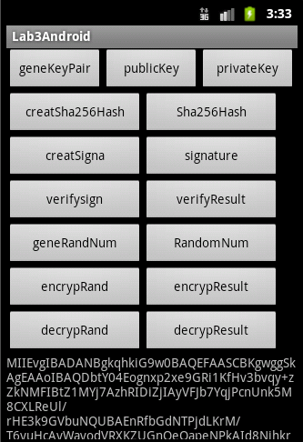
Step 2
Create a SHA-256 hash

Click createSha256Hash and then click Sha256Hash to show the hash
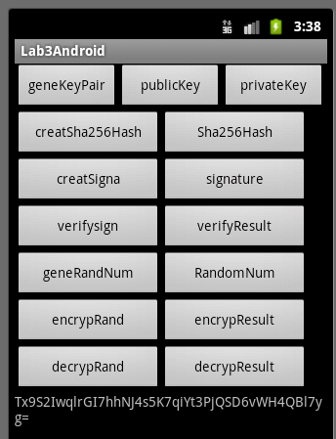

Step 3
Create a signature using SHA-256 with RSA

Lick creatSigna and then click signature

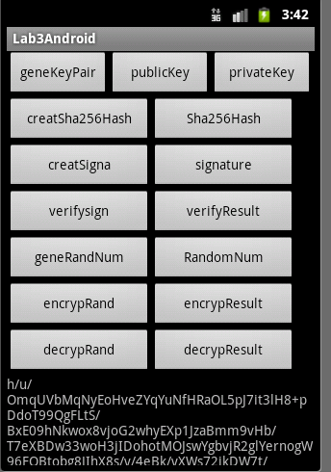

Step 4
Verify the signature

Click verifysign and then click verifyResult
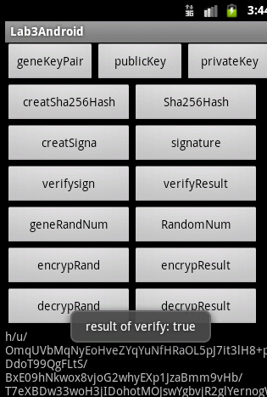

Step 5
Create a secure random number
Click geneRandNum and then click RandomNum
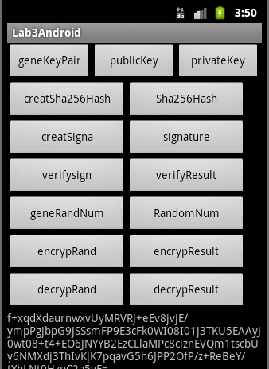
Step 6
Encrypt the random number
Click encrypRand and then click encrypResult
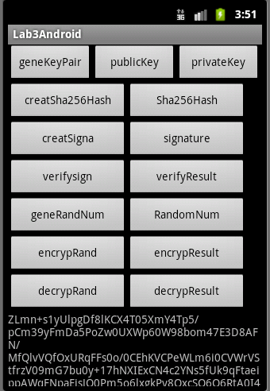
Step 7
Decrypt the encrypted file

Click decrypRand and then click decrypResult
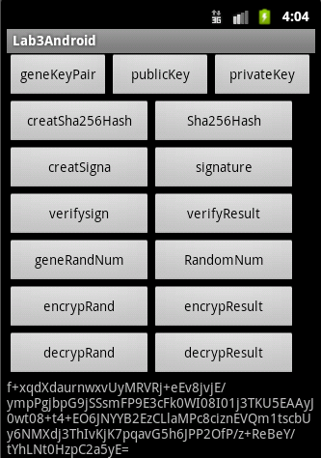
Step 8
Generate a public/private key pair for ECDSA for Binary Curve B-571
The public key:
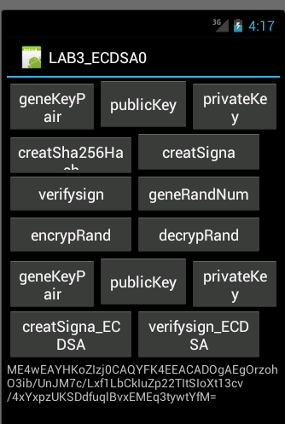
The private key
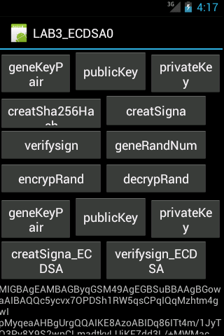
Step 9
Create a signature using SHA-256 with ECDSA decryption.
The signature
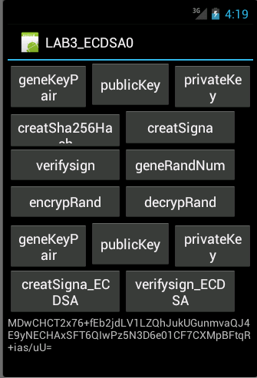
Step 10
Verify the signature

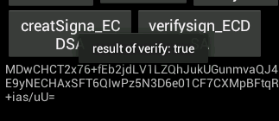

Result
All of the steps in this lab have been completed without significant problem, in step 3 and step 4, we have two way to finish the signature and verify, one is use the method of signature object another one is just use the RSA encryption and decryption and compare their result. In the bonus, the android implement also have been done. Although the UI in android implement is not such beautiful but the basic function have been finished.

Conclusion
By using the java security library, we can easily implement the RSA signature and verify as well as the RSA encryption and decryption in JAVA language. One important thing we should draw attention to is that in RSA encryption and decryption the data size is limited.

References
- Example codes and sample solutions from Dr.Wu
- RSA application demonstrates, http://developer-content.emc.com/docs/rsashare/share_for_java/1.1/dev_guide/group__JCESAMPLES__ENCDEC__SYMCIPHER__AESGCM.html
- Spongy Castle
http://rtyley.github.com/spongycastle/#downloads
- Bouncy castle
http://bouncy-castle.1462172.n4.nabble.com/Problem-with-ECDSA-td2547380.html
http://www.bouncycastle.org/wiki/display/JA1/Elliptic+Curve+Key+Pair+Generation+and+Key+Factories

